

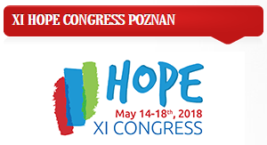

Students of hospital and sanatorium schools in Poland and schools in Europcan countries from which teachers are members of HOPE.
We invite you to participate in the first edition of the international art competition.
THIS THOROUGH TOPIC: "The world through child’s eyes"
Please send the works to the following address:
Primary School No. 38 Special
ul. Ks. K. Damrota 33
41-800 Zabrze
POLAND
The deadline for submitting works: 1/03/2018 to 30/04/2018.

